-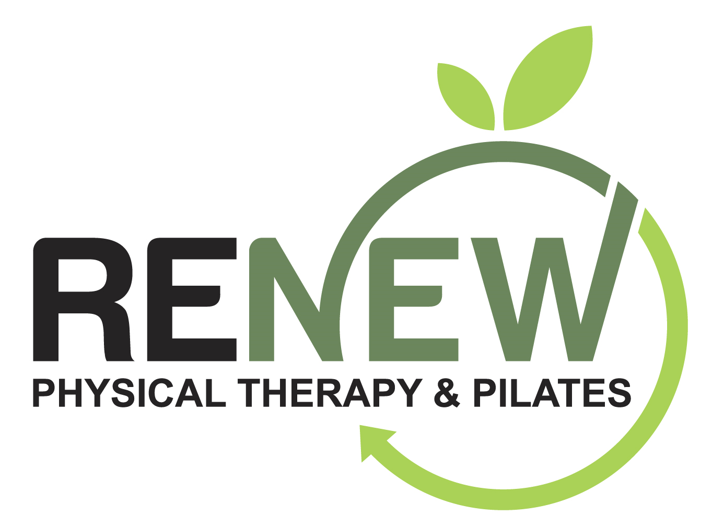
FOCUS SHOCK WAVE THERAPY QUESTIONNAIRE & INFORMATION

What is Shock Wave Therapy?
Shock Wave Therapy (SWT) involves the delivery of sound waves via an electromagnetic handpiece or a pneumatic handpiece to deliver high-pressure peak energy to superficial and deep tissues for therapeutic effect to improve blood flow, activate connective tissue, stimulate stem cells, and reduce pain. Here at Renew Physical Therapy & Pilates, we use the Chattanooga Focus Shock Wave Therapy unit and the Storz Medical Radial Shock Wave Therapy unit. SWT has been in use in the medical community since the 1980s with much research internationally. In the United States, the use of SWT for plantar fasciitis is FDA approved. Based on the same principles of soft tissue healing, the use of SWT can be therapeutic in treating many other soft tissue issues. The Focus SWT unit allows for the treatment depth to go from superficial (3cm depth) to as deep as 12.5 cm to treat many issues. The Radial SWT unit can treat more superficial and a broader area of tissues.

What to Expect with Shock Wave Therapy?
Ultrasound gel over the treatment site for improved conduction, then the applicator head is slowly moved over the involved area to find the specific site in the soft tissue with increased sensitivity. This can be both diagnostic as well as therapeutic helping your practitioner to identify specific sites of soft tissue dysfunction. You will feel a deep ache and some discomfort, ideally a 6 out of 10 pain. There needs to be a moderate amount of discomfort at the treatment site(s) to achieve maximal effectiveness. Within 60-90 sec this site should reduce to a 2 out of 10 pain level and then the applicator will be moved to another site. Multiple sites within the treatment area will be addressed during your treatment session to achieve optimal therapeutic effect. Typically 3-6 visits will be needed to achieve maximal benefit and promote optimal soft tissue healing principles.

Risks/Side Effects of the Procedure
Though unlikely, there are risks associated with this treatment. Bruising and post treatment soreness are the most common but often there is an immediate analgesic (pain relieving) effect of the SWT treatment. Please consult with your practitioner if you have any questions regarding the treatment above.
*Your therapist was trained and has met requirements for competency in the delivery of Shock Wave Therapy. Post treatment use of heat is advised and avoiding NSAIDs and ballistic activities such as jumping, plyometrics, running for 48 hours.
Do you have a pacemaker or any other electrical implant? No Yes ________________________________________
Any coagulation disorders (difficulty with blood clotting)? No Yes _________________________________________
Are you taking any blood thinners? No Yes ___________________________________________________________
Any metal/hardware anywhere in the body (spine fusion, joint replacement)? No Yes _________________________
Any active cancer/malignancy? No Yes _____________________________________________________________
Any DVT issues (deep vein thrombosis, blood clot) No Yes _____________________________________________
FEMALES: Are you pregnant? No Yes ______________________________________________________________
Any corticosteroid use/injection in the past 6 weeks? No Yes_____________________________________________
STATEMENT OF CONSENT I confirm that I have read and understand the above information, and I consent to having Shock Wave Therapy treatment. I understand that I can refuse treatment and stop at any time.

Patient Name (Print):___________________________________ Signature:_________________________________
Physical Therapist Signature:__________________________________ Date:_______________________________

