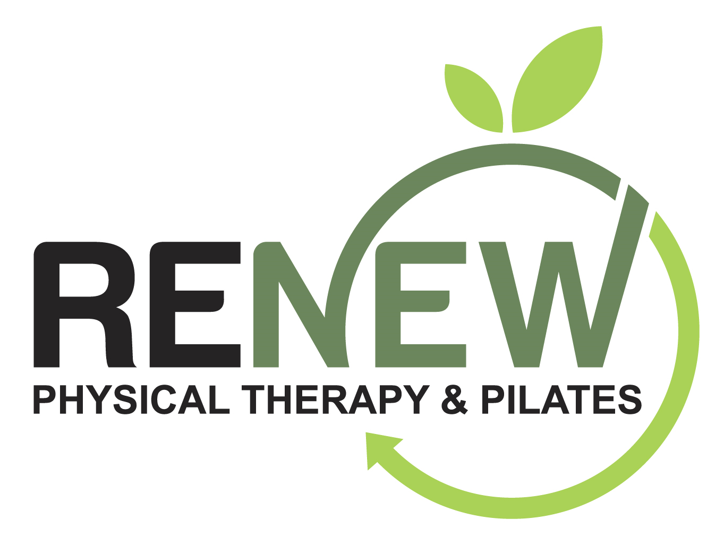
Post Shock Wave Therapy (SWT) Treatment Guidelines

~~~~~~~~~~~~~~~~~~~~~~~~~~~~~~~~

Focus SWT (fSWT) is a regenerative treatment tool intended to promote your body’s natural healing response by working on the cellular level. It delivers high-energy sound waves precisely targeting a specific area of dysfunctional soft tissue to stimulate the body’s natural healing process. It is non-invasive. It can be used to treat a variety of conditions including chronic muscle and joint pain, tendonitis, tendinosis, plantar fasciitis, and other sports and over-use related conditions.

How does fSWT work? These focused acoustic waves penetrate deep into the tissues triggering the release of growth factors, enhancing blood flow, and the formation of new blood vessels to stimulate the body’s own healing processes leading to improved pain relief, faster recovery, and longterm benefits.

Recommendations Post fSWT:
Stay hydrated (drink an extra 10-16 ounces of water)
Gentle stretches and eccentric exercises as prescribed by your practitioner
Tylenol and heat as needed for post-treatment soreness
Take Vitamin C, Collagen and Co-Q10
Reduce your workouts and physical activity to 50% for 48 hours post-treatment

Things to avoid for 48 hours post treatment:
NSAIDS [Advil (Ibuprofen) and Aleve (Naproxen)]
Ice to the treatment area
Jumping, running or other ballistic activities

Things to consider:
The more chronic your soft tissue issue the more treatments may be required
Research indicates 3-6 visits are most common with the more chronic conditions requiring more sessions
Active healing is always best - walking, biking, staying active while your body heals
Smoking, drinking alcohol, eating an inflammatory diet, sedentary lifestyle can negatively impact and slow your healing process

