Medical History Information

Name:_____________________________________________ DOB:______________________________

Address:_________________________________ City:_____________________________________

State:_______ Zip:__________ Phone #:___________________ Text Reminders ok? Y N

Is your above address also your billing address for credit card on file? Yes No

Do you have Medicare coverage for your health insurance? Yes No

COVID-19 Vaccination? Yes No Date of last vaccination shot? __________________________

Booster? Yes No Date of Booster shot?____________________

Email:________________________________________________________________________________

Emergency Contact Name:________________________________ Phone #:_____________________

Relationship to you:______________________________________

Occupation (past or present):______________________________________________________________

How were you referred/recommended to us:__________________________________________________

Primary Physician: ______________________________________ Phone #:_____________________

Specialist Physician:______________________________________ Phone #:_____________________

Did you inform your physician that you are starting Physical Therapy and/or Pilates? Yes No

Have you had any change in health status over the last 12 months? Please include any injuries, surgeries, new diagnoses or new medication. __________________________________________________________________________________________________________________________________________________________________________________________________________________________________________________________________

Please list all supplements, over the counter and prescription medications that you are taking:
1._______________________ 2.______________________ 3.________________________
4._______________________ 5.______________________ 6.________________________
7._______________________ 8.______________________ 9.________________________

Women: Are you (or could you be) pregnant? Yes No

Number of pregnancies:______ Vaginal or Cesarean delivery (circle)

Have you or any immediate family member (parent, sibling, child) been told you have (circle):

Allergies Depression Liver Disease
Arthritis Diabetes Osteoporosis/Osteopenia
Asthma Eating Disorder Shortness of Breath
Cancer Heart Problems Skin Problems
Chemical Dependency High Blood Pressure Stroke
(alcohol/drugs) Joint Replacement Thyroid Problems
Circulation Issues Kidney Disease Varicose Veins

If any are circled, please explain:__________________________________________________

Please mark any areas of symptoms in your body
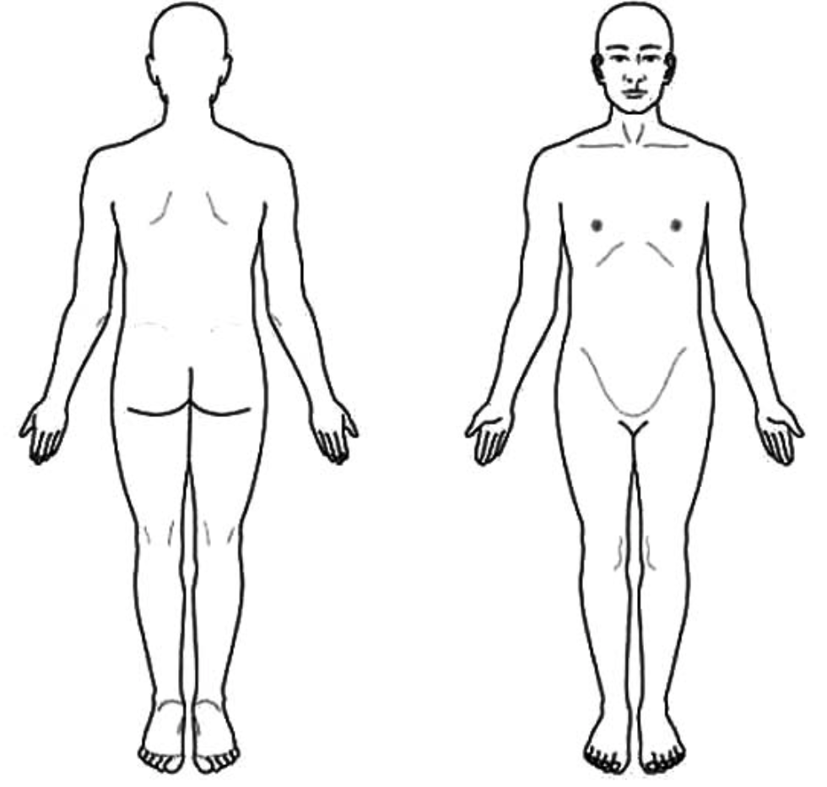

On a scale of 1-10, what is your current pain level?_______ Best:________ Worst:________

My signature gives my consent to be treated. I understand that I always have a right to refuse treatment and/or ask questions for any reason if I am uncomfortable with the options recommended.

___________________________ _________________________________ ____________________
Patient/Client name (print) Signature Date
(or parent if minor)

